IFM OS
Final Frontend Redesign
Storyboard + Claude Build Prompt
Premium editorial content discovery — with honest media playback.

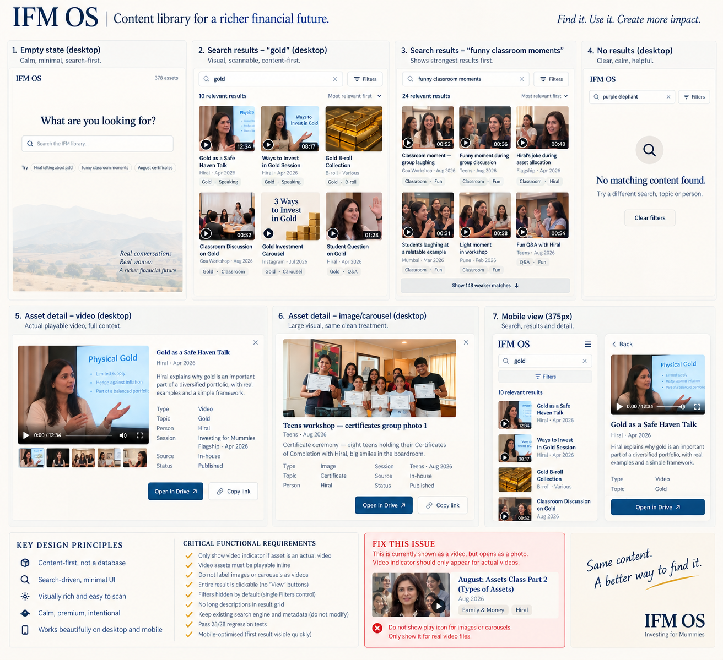
Visual direction / storyboard — use as the design reference, not as final placeholder content.
NON-NEGOTIABLE
The search engine is approved and frozen. Redesign the frontend only. Never show a play control or video player unless an actual playable video file exists.

1. What the redesign must achieve
- Turn the current database/DAM-style interface into a premium editorial creative library.
- Make visual scanning the primary discovery mechanism: IMAGE → SHORT TITLE → QUIET CONTEXT.
- Keep the approved search engine, metadata, taxonomy and 28/28 regression suite unchanged.
- Make media integrity explicit: actual video = playable; image/carousel = image treatment; video record without an accessible master = honest “Preview unavailable” treatment.
- Preserve the core Aakara outcome: find the exact IFM asset without talking to Sakshi.
2. Critical problem discovered
Current failure: an asset can be labelled VIDEO · HIRAL SPEAKING, but clicking it opens only a still image. This must not happen in the redesigned product.
- Do not infer playback capability from the Type field alone.
- Do not infer a video from a video-looking thumbnail.
- Do not invent a media URL.
- Audit the actual media mapping before implementing the final frontend.
- If only a thumbnail/still is available, show the still and clearly say “Video preview unavailable”, with Open in Drive.
3. Visual direction
- Premium, editorial, calm, warm, intelligent, confident and minimal.
- Content-first rather than dashboard-first.
- Think premium editorial archive / Google Photos-style visual discovery, not Airtable, Notion or a SaaS DAM.
- Avoid gradients, glows, bright colours, excessive pills, heavy cards, visible scoring and technical/developer UI.
- Desktop result architecture: restrained 3-column visual gallery.
- Filters remain hidden behind one compact Filters control.
4. Core UI states in the storyboard
Empty state — Quiet search-first screen. IFM identity, “What are you looking for?”, one dominant search field and three subtle examples. No giant landing-page hero.
Search — gold — Visual 3-column results. Large real thumbnails. Short titles. Quiet context such as “Hiral · Apr 2026”. Actual videos get subtle play indicators only when playable.
Search — funny classroom moments — Strongest relevant visual results first. Weaker matches remain behind a quiet “Show weaker matches” control.
No results — For “purple elephant”: calm “No matching content found.” Never show vaguely related assets.
Video detail — Large, genuinely playable video when an actual video exists. Minimal metadata and clear Open in Drive action.
Image / carousel detail — Large visual with no fake video controls. Same clean metadata treatment.
Mobile 375px — IFM → Search → Filters → Results. First content appears quickly. No horizontal scrolling. Detail view puts media first.
5. Media behaviour rules
Asset reality | Frontend behaviour
Actual playable video exists | Video thumbnail + subtle play indicator + real playable preview + controls.
Image | Image only. No play icon. No video controls.
Carousel | Cover image only. No play icon. Identify as carousel in detail.
Metadata says Video, but no playable master is available | Still/thumbnail only. No play icon or fake player. Detail says “Video preview unavailable” + Open in Drive.
6. Brand system
- IFM Navy #0C548E
- Warm Ivory #FCFAF7
- Soft Cream #F7F1E8
- Stone #E9E2D8
- Muted Gold #E5C76B
- Charcoal #24313F
- Typography: Lora for editorial/display moments; Inter or similarly refined sans-serif for UI/body.
7. Claude implementation prompt
IFM OS — FINAL FRONTEND REDESIGN + MEDIA INTEGRITY BRIEF
STOP AND READ EVERYTHING BEFORE CODING.
You are acting as:
- Senior Product Designer
- Senior UX Designer
- Senior Frontend Engineer
- Media-library architect
I am providing:
1. The original IFM frontend redesign brief
2. Screenshots of the current implementation
3. A visual storyboard showing the intended product
4. A screenshot exposing a critical media-preview problem
Your job is to redesign the frontend AND make sure the UI never misrepresents the underlying media.
==================================================
PART 1 — FREEZE THE APPROVED SEARCH ENGINE
==================================================
The search engine is approved.
DO NOT MODIFY:
- search logic
- ranking/scoring
- taxonomy
- catalogue
- data.js
- metadata
- synonyms
- relevance cutoff
- weaker-match logic
- search indexing
- 28/28 regression suite
Do not “improve” the search engine while doing the frontend.
==================================================
PART 2 — CRITICAL MEDIA INTEGRITY PROBLEM
==================================================
THIS IS NOW A P0 ISSUE.
The current UI can show an asset as VIDEO · HIRAL SPEAKING, but clicking it may open only a still image.
This is unacceptable.
The interface must NEVER imply that an asset is a playable video unless an actual video file is available.
Before redesigning the final frontend, audit the media mapping for:
- asset ID
- metadata type
- thumbnail URL/path
- actual media URL/path
- whether playable
- whether image/video/carousel
- whether current frontend incorrectly treats anything as video
Do NOT guess.
Do NOT invent a video URL.
==================================================
MEDIA RULES
==================================================
IF ACTUAL VIDEO FILE EXISTS:
- video thumbnail
- subtle play indicator
- duration if available
- genuinely playable video in detail view
IF IMAGE:
- image only
- NO play icon
- NO video controls
IF CAROUSEL:
- cover image
- NO play icon
- NO video controls
IF METADATA SAYS VIDEO BUT ACTUAL VIDEO FILE IS NOT AVAILABLE:
- show available still/thumbnail
- NO fake play icon
- NO fake player
- detail says “Video preview unavailable”
- Open in Drive remains available
A video-looking thumbnail is NOT evidence that a video file exists.
A Type = Video field is NOT enough to create a video player.
==================================================
PART 3 — REDESIGN THE FRONTEND
==================================================
The current frontend looks like a DAM/database/SaaS dashboard.
That is NOT acceptable.
It needs to feel like a premium editorial creative library.
The user should think:
“I know what I need. I type it. I see the content. I click it. I’m done.”
==================================================
PART 4 — RESULT ARCHITECTURE
==================================================
DELETE THE CURRENT HORIZONTAL RESULT-ROW COMPOSITION.
Do not polish it.
Replace it with a restrained editorial gallery.
Desktop:
- 3-column visual grid
- large thumbnails
- generous spacing
- clean typography
- no card shadows
- no excessive borders
- no giant rounded SaaS cards
Each result:
LARGE VISUAL
Short title
Quiet context
Optional minimal metadata
Example:
[ LARGE IMAGE ]
Gold as a Safe Haven Talk
Hiral · Apr 2026
Gold · Hiral Speaking
Do NOT show the long AI-generated description in the result grid.
Keep it in the data for search/indexing.
Reveal fuller description in detail view.
==================================================
PART 5 — SEARCH
==================================================
Empty state:
- IFM identity
- “What are you looking for?”
- one search field
- three subtle examples
- no giant marketing hero
- no taxonomy explanation
- no developer language
When the user searches, the hero collapses naturally into a compact search bar.
Results:
gold
10 relevant results
Filters
Then visual results.
Filters remain hidden by default and open only when clicked.
==================================================
PART 6 — DETAIL VIEW
==================================================
Create three honest states:
A. ACTUAL VIDEO
- large playable video
- real controls
- title
- context
- metadata
- Open in Drive
- Copy link
B. IMAGE / CAROUSEL
- large image
- no fake video controls
- title
- metadata
- Open in Drive
- Copy link
C. VIDEO RECORD WITH NO PLAYABLE MASTER
- available still/thumbnail
- no play controls
- “Video preview unavailable”
- Open in Drive
==================================================
PART 7 — MOBILE
==================================================
375px is first-class.
Hierarchy:
IFM
Search
Filters
Results
First result should appear quickly.
No giant hero.
No filter wall.
No horizontal scrolling.
Minimum touch target 44px.
Detail:
media first
title/context
metadata
Open in Drive
==================================================
PART 8 — BRAND
==================================================
IFM Navy #0C548E
Warm Ivory #FCFAF7
Soft Cream #F7F1E8
Stone #E9E2D8
Muted Gold #E5C76B
Charcoal #24313F
Typography:
Lora + Inter (or similarly refined sans-serif)
Feeling:
premium, editorial, calm, warm, intelligent, confident, minimal.
Avoid:
gradients, glows, bright colours, excessive pills, excessive cards, dashboard widgets, visible scoring, AI gimmicks, technical UI.
==================================================
PART 9 — USE THE STORYBOARD
==================================================
Use the supplied storyboard as the visual direction.
Do not blindly copy placeholder imagery.
Use real IFM assets.
The storyboard demonstrates:
1. Empty search
2. Gold results
3. Funny classroom results
4. No results
5. Actual playable video detail
6. Image/carousel detail
7. Mobile
The critical rule is:
ONLY ACTUAL VIDEOS GET PLAY CONTROLS.
==================================================
PART 10 — RENDER AND INSPECT
==================================================
Render at:
1440
1024
768
375
Actually inspect screenshots.
Do up to 3 focused visual iterations:
1. Render
2. Inspect
3. Identify the 3 biggest visual weaknesses
4. Fix them
5. Render again
Do not endlessly tweak.
==================================================
PART 11 — REGRESSION
==================================================
Run the full 28/28 search regression.
Then test:
gold
gold investments
gold jewellery
gold b-roll
funny classroom moments
Hiral explains SIP
purple elephant
blue hat
portrait
XIRR
CAGR
ETF
REIT
insurance
August certificates
Also test:
- search
- result click
- detail view
- actual video playback where available
- image preview
- carousel preview
- unavailable-video state
- Drive link
- Copy link
- filters
- clear search
- new search closes detail
- mobile
==================================================
PART 12 — AAKARA ACCEPTANCE TEST
==================================================
Run:
1. Find a video of Hiral talking about gold.
2. Find funny classroom footage.
3. Find August certificates.
Correct assets should appear in the strongest results.
If an actual video exists, it must be playable.
If no playable video exists, clearly say preview is unavailable and provide Drive.
Never mislead the user.
==================================================
FINAL PRODUCT STANDARD
==================================================
YES to:
Can Aakara find the exact IFM asset without talking to Sakshi?
YES to:
Can she visually recognise content without reading a database-style paragraph?
YES to:
Does the interface accurately represent whether the underlying media is actually available?
The product must never show a video player or play control unless an actual playable video exists.
Do not touch the live hub.
Work only on the V1 prototype.
Same content.
A much better way to find it.
8. Final acceptance checklist
☐ 28/28 search regression remains green.
☐ Gold results are visually led by relevant Gold-topic assets.
☐ Purple elephant / blue hat produce no false results.
☐ Filters are hidden by default.
☐ Result grid is visual and editorial, not database-like.
☐ Long AI descriptions are not exposed in the result grid.
☐ Actual videos are genuinely playable.
☐ Images and carousels never receive fake play controls.
☐ Video records without playable masters clearly say “Video preview unavailable”.
☐ Drive remains the fallback path.
☐ Mobile 375px has no horizontal overflow and shows content quickly.
☐ Aakara can complete the three acceptance tasks without talking to Sakshi.
☐ Live hub remains untouched.
Same content. A much better way to find it.

